Erasmus Staff Training Week - University of Murcia 22-26 April 2024 Diversity and Volunteering Service

Monday 22 | Tuesday 23 | Wednesday 24 | Thursday 25 | Friday 26
INSTITUTIONAL WELCOME | OUR BUSINESS: | OUR BUSINESS: | CULTURAL VISIT: CARTAGENA | WEEK FINALE
La Merced Campus: “Hemiciclo” Faculty of Arts | Espinardo Campus: Centro Social Universitario building n.29 | Espinardo Campus: Centro Social Universitario building n.29 | Cartagena visit  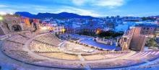 | La Merced Campus: “Antonio Soler” Room  Faculty of Arts. Ground floor
9.00-9.30:  Registration, welcome coffee  9.30-10.15:  Institutional Welcome by authorities, presentation of participants and group photo  10.15-11.30:  Group 1 (KA- 131)  The role of mobility in European Universities Initiative alliances". (Jorge Piernas).  Group 2 (KA 171) Administrative procedures  11.30-12.00  Coffee Break  12.00-13.30:  University Language Centers: a door to (multi)cultural experience  José Saura Sánchez y Juana Sanmartín Vélez.  (UMU)  14.00- Lunch  18.00:  Meeting point: Tourism Office Plaza Cardenal Belluga  2-hour guided tour around Murcia. | 9:00-10:00:  Coffee  10:00-10:15: Exploring the service: Essential ADyV  10:15-11:00:  ADYV diversity support programs  11:00–11:30: Good practices in diversity  11:30-12.00:  Coffee break  12:00 – 12:30:  International projects in ADYV: diversity  12:45 – 13:30: Innovation projects in diversity: digital developments  13.30: Lunch at Centro Social Universitario  19.45 Meeting point “Rincón de Pepe” Hotel main door  20.00: Welcome Dinner  “Rincón de Pepe” restaurant | 9:30 -10:00: Coffee  10:00–10:45: ADYV  volunteer programs  10:45–11:30: Good  practices in volunteering at the UMU  11:30-12.00: Coffee break  12:00–12:30: International projects in ADYV: volunteering  Free time | 8.30: Meeting point: Mercadona Plaza Circular  8.45: Bus to Cartagena  9.30-11.30: Guided tour around Cartagena. https://www.turismore giondemurcia.es/es/ca rtagena/  11.30- 12.00:  Free time  12.00-13.30:  Visit to Roman forum museum  https://puertodeculturas.cartagena.es/ficha_barrio_foro.asp?idioma=2  13.45:  Bus to Cabo de Palos Beach  14.30:  Lunch at seaside restaurant  16. 00 :  Free time at Cabo de Palos. (Visit to the lighthouse) https://www.turismore giondemurcia.es/es/ca bo_de_palos/  18.30: Bus to Murcia | 9.30 – 10.00:  The Faculty of Law: good practices in Internationalization  10.00-10.30:  Equipping student ambassadors as agents to improve mobility experiences.  Aulario La Merced (canteen)  10.30-11.30: Coffee  break  Sala Albatros:  Aulario La Merced  11.30-12.00: Survey  and conclusions  “Antonio Soler” Room  12.00-12.30:  Certificates and farewell.
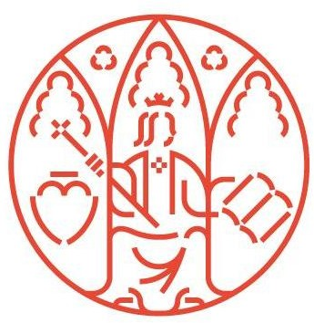
** All activities are intended only for participants in UMU Staff Week, lunches and dinner are free of charge

Área de Relaciones Internacionales
Edificio Rector Soler Campus Espinardo 30100 — Murcia ESPAÑA

internacionales@um.es
Tlf.: +34 868 88 40 74 um.es

